DockPanel for VB.NET
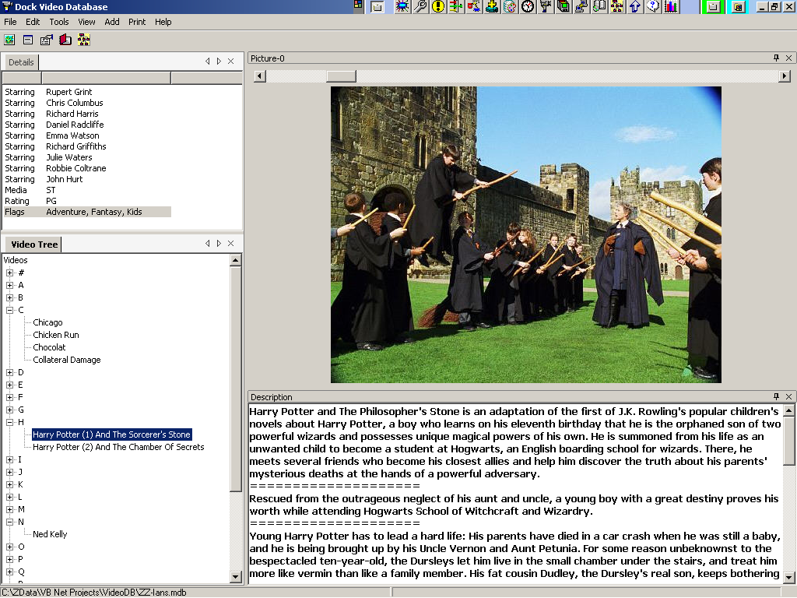

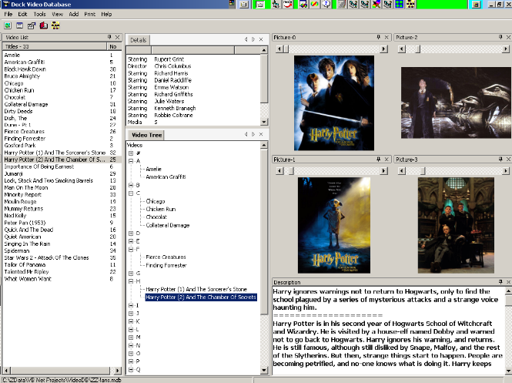

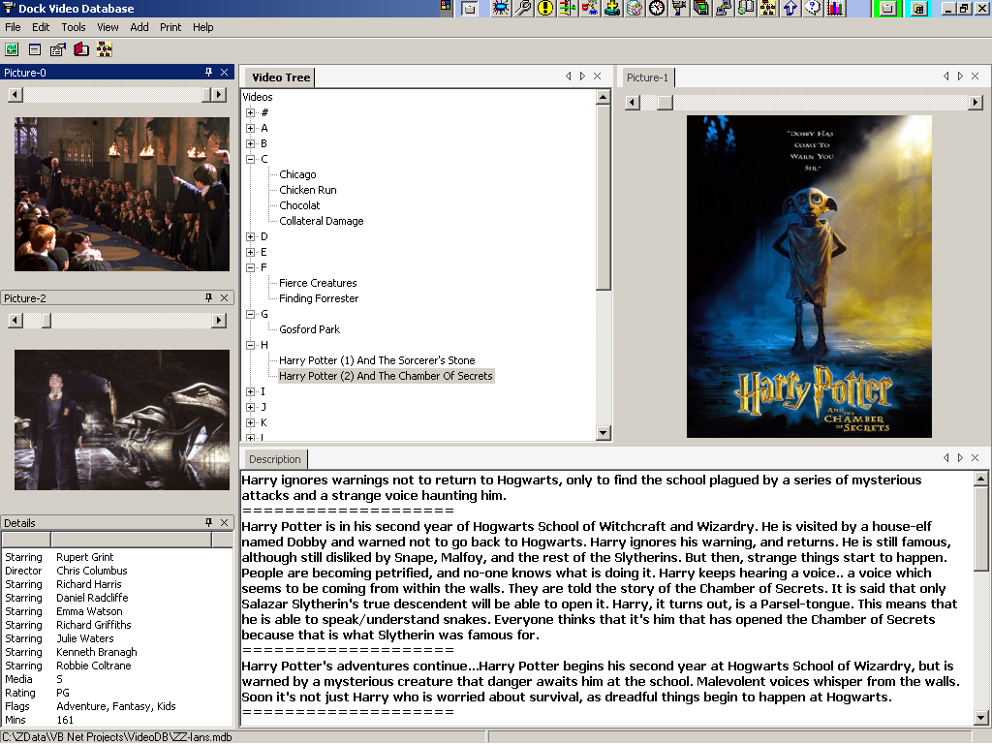

A Beginners Cookbook

Contents
1. Introduction 3
What is this? 3
Who might use this 3
About the DockPanel Suite 3
What to do first 4
The Most Important Bits 4
2. My First Project 5
Getting a Reference 5
Getting a Different Reference… 5
The Main Form 5
The Main Form 6
3. My Second Project 8
The Main Form 8
DockContent Factory 10
Windows Collection 11
Saving the DockContent layout 11
Overriden Subs implementation 12
Final Thoughts 13
4. Appendix A – frmChildForm 15
5. Appendix B – Forms Custom Collection 16

This cookbook is based on Version 98.0.3 (Jan 2005) of DockPanel Suite and is written by CaptF (CaptF@HotMail.Com). It is not authorised nor endorsed in any way by the author of the product.

Document Version 1.0 – 27 Jan, 2005

Introduction

What is this?
This cookbook is written to help VB.NET users to start using the DockPanel Suite quickly. It gives guidance on how to start using the classes and highlights some design considerations.
I developed it out of notes I was making for myself as I starting using the DockPanel Suite for the first time and should get you running a trivial app using DockPanel Suite inside 10 minutes.
We will walk through a couple of simple projects, looking at the basic design features relevant to the use of the DockPanel Suite. This guide is not meant to be comprehensive – the official documentation and the source code does that job. This just tells you where to start.

Who might use this
Almost any beginner will quickly be able to get a project working in DockPanel Suite with the help of this cookbook. Unlike most cookbooks, it even has many of the ingredients included!
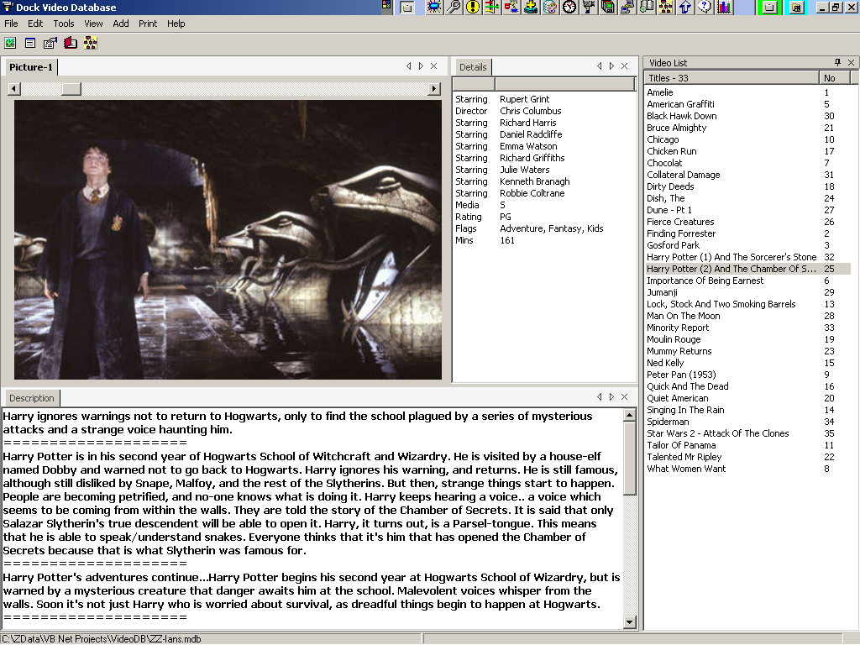
I would think that most “professional” programmers would find this pitched a little low for them although, if new to the DockPanel Suite, it will be a useful overview of the essentials.

About the DockPanel Suite
DockPanel Suite is written in C# by Weifen Luo. It is designed to achieve docking capability for MDI forms similar to that provided in Visual Studio.
Weifen welcomes all kinds of feedback - good or bad, he says! Please contact him at: weifenluo@yahoo.com.
Links for the latest version:
http://www.freewebs.com/weifenluo/DockPanel.htm
This is Weifen Luo’s personal web site
or
http://sourceforge.net/projects/dockpanelsuite/
From here, you can get release notification, post messages in the forum, make donation or participate the project, etc)

What to do first
Before starting on this guide, read (or at least, be familiar with) all of Weifen’s documentation. It is fairly comprehensive & gives you everything there is to know about DockPanel Suite. This cookbook gives you only what you need to know.

The Most Important Bits
At the very start you need to know a couple of things:
- All your MDI child forms now become DockContent objects. The DockContent object inherits from the System.Windows.Forms.Form so you will be quite at home with the new object and it will have all the familiar properties that you expect to be able to use.
The additional methods, properties etc of the DockContent object allow it to be manipulated on the screen without your needing to write any additional code.
- The function of an MDI parent form is now performed by the DockPanel object.
- If you want to re-create the screen at startup just as the user left it, you need to provide a PersistString. This is a property of the DockContent object that you provide to the DockPanel Suite. DockPanel Suite will pass it back at startup and expect you to re-create the DockContent object as you left it. The PersistString value could just be a form name, file name or even some key into the registry to retrieve a set of parameters. You will need to write a function that takes the PersistString as a parameter and returns the DockContent object as the result of the function.
Don’t worry (yet) - all of these points, and others, will be expanded later.
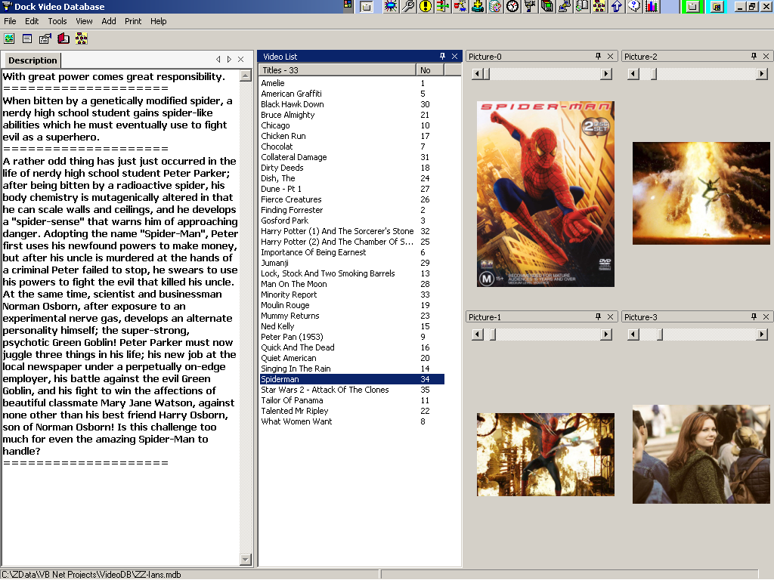

The First Project
This is a simple test outline that doesn’t do much at all. It is, however very short to type in and useful to allow you to play with the various docking options straight away. You should be playing within five minutes.
Start a new Windows Application project.

Getting a Reference
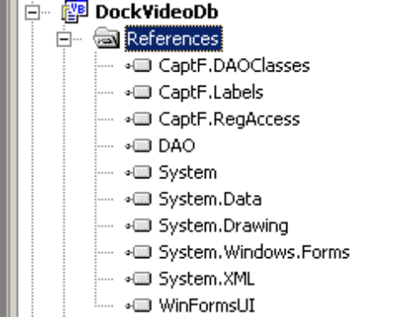
Once you have started your new project, you need a reference to the DockPanel Suite. This approach assumes you have the C# module of Visual Studio installed as well as the VB one.
Weifen makes the DockPanel Suite source (in C#) available on the web. Download it, unzip the project and save it on your disc somewhere.
In your project, select the Solution node in the Solution Explorer, right-click to get the menu; choose Add/Existing Project…
Navigate to the WinFormsUI.csproj file in the WinFormsUI project and open it. The WinFormsUI project is imported.
In your new project, right-click on the References node, choose “Add Reference”, choose the “Projects” tab, double-click on “WinFormsUI” and click the “OK button. You should see something like this diagram. Note the “WinFormsUI” entry.

Getting a Different Reference…
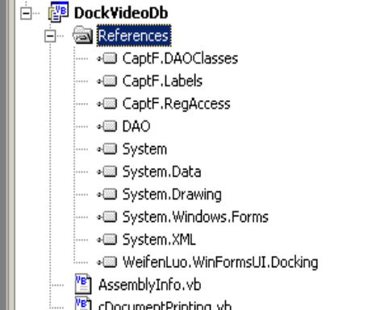
If you don’t have the C# module installed in Visual Studio, or just plain don’t want to import the source code into your solution, then you can use the Dynamic Link Library (DLL) that the DockPanel Project produces. This is also available from the websites.
Firstly, put the DLL somewhere safe on the your machine. This could be either the global cache (see a book for how to do this) or you might consider just putting it in the bin directory under your new project.
In the IDE, right-click on the References node under your project and choose “Add Reference…”.
In the dialog form click the “Browse …” button and navigate to the DLL. Double-click to select it and click OK. This time you should see something like this diagram. Note the “WeifenLuo.WinFormsUI.Docking” entry.
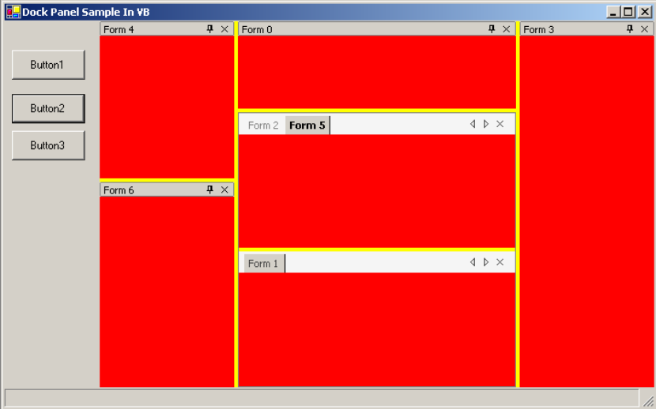

The Main Form
Declare a form variable called dckPanel as below.

Dim dckPanel As WeifenLuo.WinFormsUI.DockPanel
Set the Main form WindowState to Maximised.
Find the “New” Sub – usually hidden in the "Windows Form Designer generated code" region. Add the Dock Panel initialisation code shown in bold below.

Public Sub New()
MyBase.New()

'This call is required by the Windows Form Designer.
InitializeComponent()

'Add any initialization after the InitializeComponent() call
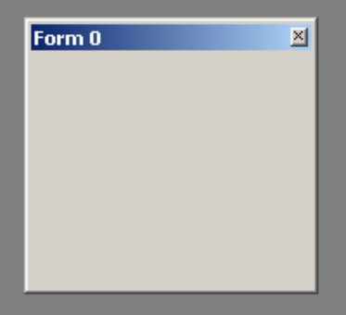A floating window
'
' Add the Dock Panel
'
Me.SuspendLayout()
dckPanel = New WeifenLuo.WinFormsUI.DockPanel
With dckPanel
.Parent = Me
.Dock = DockStyle.Fill
.BringToFront()
End With

Me.ResumeLayout()

End Sub
This will load the DockPanel when the form in instantiated. The DockPanel is the container, similar in function to the MDI master form, that will contain the DockContent objects (“child forms”) that we will create next.
The BringToFront stops the DockPanel tucking itself under the panel we are just about to put on the form.
Put a panel on the form, dock it to the left and put a button in the panel. Attach this code to the click event of the button.
Private Sub Button1_Click(ByVal sender As System.Object, _
ByVal e As System.EventArgs) _
Handles Button1.Click

Static nCount As Integer = 0

Dim frmX As New WeifenLuo.WinFormsUI.DockContent
frmX.ShowHint = WeifenLuo.WinFormsUI.DockState.Float
frmX.Text = "Form " & nCount.ToString
frmX.Show(dckPanel)

nCount += 1

End Sub
Run the project.
Every time you click the button, you will get a new DockContent (“child form”) that floats above the form. It floats due to the “ShowHint” property set in the code above. You can now drag the child form to the sides of the DockPanel – i.e. the body of the main form, and see it dock.
It is the location of the mouse icon that dictates how the window will dock. Inside another pane you can share (show the tabs of the contained windows) or split ( each window takes half of the space, vertically or horizontally. Double click on the title bar (or tab) to toggle a window between floating and docked.
One thing: - depending on the colour setup of your screen the docking suggestion (grey window outline) can sometimes be hard to see. Setting the BackColor of the DockPanel doesn’t seem to make any difference.
Experiment with the “ShowHint” property to see what it does. You could add a set of RadioButtons or a DropDownCombo to the panel to control the value of ShowHint.
If the child form fills the DockPanel – removing the header bar – you can drag the tab of the form to detach it again.
Put two more buttons in the panel. Attach this code to them
Private Sub Button2_Click(ByVal sender As System.Object, _
ByVal e As System.EventArgs) _
Handles Button2.Click

Dim dc As WeifenLuo.WinFormsUI.DockContent
For Each dc In dckPanel.Contents
dc.BackColor = Color.Red
Next

End Sub

Private Sub Button3_Click(ByVal sender As System.Object, _
ByVal e As System.EventArgs) _
Handles Button3.Click

Dim dc As WeifenLuo.WinFormsUI.DockContent
For Each dc In dckPanel.Contents
dc.BackColor = Color.Green
Next

End Sub
You will find that it easier to see the docking suggestion when the child forms are coloured. These routines also demonstrate that we can iterate through the DockContent objects, no matter what the configuration of the child windows.
That was easy enough, wasn’t it? Next we’ll look at a more practical project.
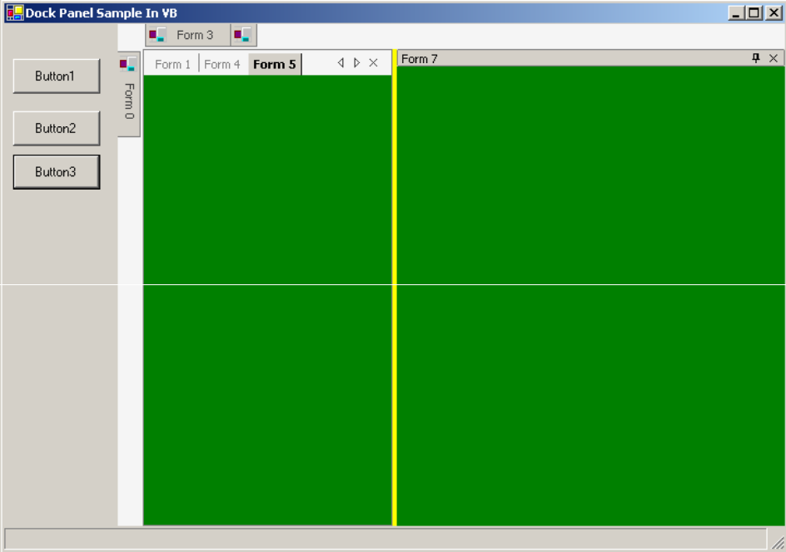Seven child forms (five hidden)

The Second Project
For my second project I took a simple video database that I’d written earlier and converted it to use the DockPanel Suite. This had the advantage that I already had all the objects and logic for the program – all I needed to change was the presentation layer.
The original version kept various details about each video, such as Title, stars, year, duration, summary, medium (VHS, DVD etc) as well as one or more pictures – typically the cover of the DVD or promo shots from the web.
Using DockPanel Suite, I wanted to be able to present the list of movies in various orders;- alphabetical, by star, by year etc and to have the other windows (details, pictures, description) keep up with whichever one was clicked last, no matter which window was clicked.
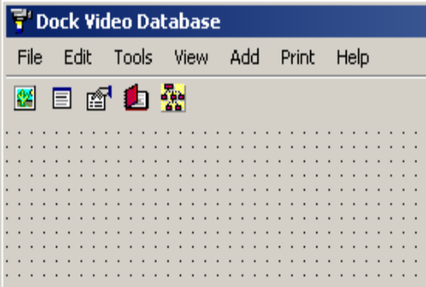

The Main Form
For the main form I used a blank form, as before, but with the additional of a toolbar with icons to start each window as required.
In addition, a MainMenu was used to:-
- Print lists
- Open or Create a different database
- Start the child windows
- Add a new video

The DockPanel was declared as a form variable and initialised as in the previous project.
In the Master Form Load routine this time, I had logic to set up the screen just as the user left it. DockPanel Suite provides the LoadFromXML routine to compliment the SaveToXML sub seen later.
Private Sub frmMaster_Load(ByVal sender As Object, _
ByVal e As System.EventArgs) _
Handles MyBase.Load

Dim configFile As String = _
System.IO.Path.Combine(System.IO.Path.GetDirectoryName( _
Application.ExecutablePath), "DockPanel.config")

If System.IO.File.Exists(configFile) Then
' Params to LoadFromXml are:
' - XML Config file
' - Pointer to the Fn that takes a Persist String &
' returns a DockContent object
dckPanel.LoadFromXml(configFile, AddressOf mdck_BuildDockContent)
Else
' Load a basic layout
m_ViewVideoList()
m_ViewPicture()
End If

End Sub
You don’t need to know how “LoadFromXML” works. I don’t.
It was the callback (“AddressOf …”) that caused me most problems getting the syntax correct. This is probably the most useful bit of info you will find in this document. Weifen’s documents show how to use Delegates and virtual routines in C#, but, in this respect, Visual Basic is infinitely simpler.
My mdck_BuildDockContent routine is the function referred to in the Introduction that takes the PersistString and returns a DockContent object. When you call the ‘LoadFromXML’ routine it will handle all the layout logic, but it needs you to supply it with the DockContent objects.
Next we look at how I did it.

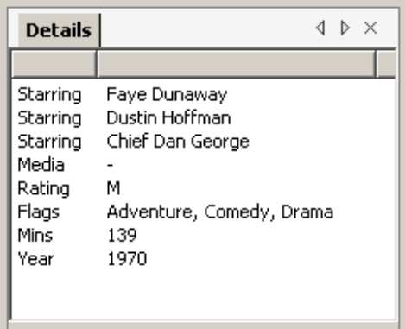The Details window
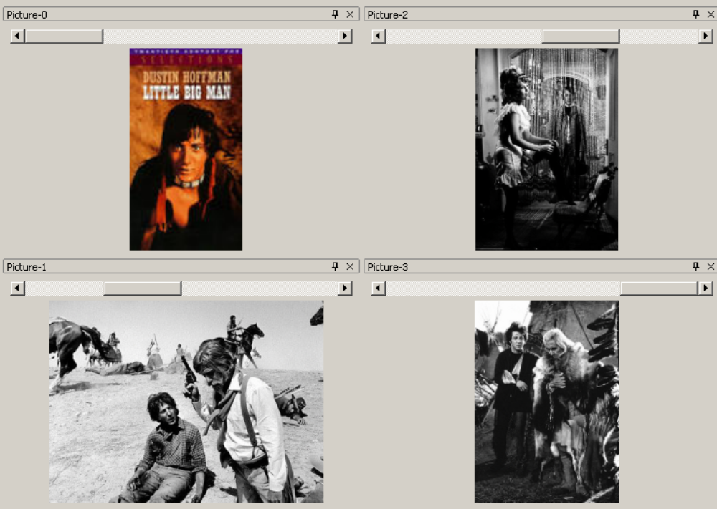Four Picture windows – each with a unique name (which is the same as the caption)

DockContent Factory
If you want DockPanel Suite to re-create the application layout just as the user left it, you have to provide the DockContent factory function that builds the DockContent object from the PersistString.
Here’s the one I developed. It doesn’t matter what it’s called as long as the signature is correct.
Private Function mdck_BuildDockContent(ByVal persistString As String) _
As WeifenLuo.WinFormsUI.DockContent

Console.WriteLine(persistString)

'
I didn’t want duplicate forms. If the user asked for the details form when there was one already on the screen, I send back a reference to the existing one. If it is hidden this will pop it out. Either way the form will get the focus.
' What we do first is scan all the existing
' forms to see if this form already exists
'
Dim cf As frmChildForm
For Each cf In Forms
If cf.PersistString = persistString Then
Return cf
End If
Next
I DID want to be able to have more than one picture box, so each box has the PersistString of “Picture-” plus an index number.
This index number was also used to give each one a unique name for the Forms collection.

If persistString.Trim.Substring(0, 7) = "Picture" Then
Dim nIndex As Integer = 0

If persistString.Trim.Length > 7 Then
nIndex = CInt(persistString.Trim.Substring(8))
End If

Dim frmX As New frmPicture(nIndex)
Return frmX
Else
Select Case persistString
For all the ‘ordinary’ windows, I just used a “Select Case …” statement to decide which window to send back.
These didn’t have any context to remember so a simple new form was sufficient.
Where forms need more info, this would be a good place to pass, say, some or all of the PersistString.
Case "VideoList"
Dim frmX As New frmVideoList
Return frmX

Case "Details"
Dim frmX As New frmDetails
Return frmX

Case "Description"
Dim frmX As New frmDescription
Return frmX

Case "VideoTree"
Dim frmX As New frmVideoTree
Return frmX

End Select
End If

End Function
The observant reader will have noticed that the returned objects were not DockContent objects. This leads us to the next design consideration.

Windows Collection
I wanted to be able to update all the windows on the screen without having to convert types every time – this meant I could not use the DockPanel.Contents collection. To this end, I did two things:
- Inherited the DockContent to make a template child form – frmChildForm (See Appendix A). This was inherited by each of my other child forms to give them all the same base set of properties, subs and functions.
- Created a custom collection that accepted and returned frmChildForms (See Appendix B).
The Forms collection is a throwback to the old VB6 days, when a Forms collection was provided for you automatically. This is better than that! In my Main module I had it declared thus:
Public Forms As New childFormCollection
This time I wanted just a collection of the child forms; then anytime something changed I could just perform an update broadcast - something like:-
Dim frm As frmChildForm
For Each frm In Forms
frm.ReDisplay()
Next

The frmChildForm has a ReDisplay sub that simply calls a protected sub – m_Redisplay. This was declared Protected (only visible by inheriting classes) and Overridable so that each inheriting class could provide the logic appropriate to its purpose.
'================================================================================
Public Sub ReDisplay()
m_Redisplay()
End Sub
'================================================================================
Protected Overridable Sub m_Redisplay()
End Sub
'================================================================================
There were a couple of other Subs with a similar strategy. See Appendix A for the full code of the frmChildForm.

Saving the DockContent layout
We can save the DockContent configuration (if desired) in the Closing event of the Master form.

'================================================================================
Private Sub frmMaster_Closing(ByVal sender As Object, _
ByVal e As System.ComponentModel.CancelEventArgs) _
Handles MyBase.Closing
' =================

Dim configFile As String = _
System.IO.Path.Combine(System.IO.Path.GetDirectoryName( _
Application.ExecutablePath), "DockPanel.config")
dckPanel.SaveAsXml(configFile)
End Sub
'================================================================================
There are opportunities here that I have yet to explore - it is clearly quite possible to offer your user multiple, uniquely-named layouts that can be loaded on demand. Each is saved to a separate file which can be loaded as required – much like the layouts in many of the Adobe products (Premiere, PhotoShop etc). How slick would that be?
When closing one layout before loading another, you might use some code like:
Do While dckPanel.Contents.Count > 0
Dim dc As WeifenLuo.WinFormsUI.DockContent = dckPanel.Contents(0)
dc.Close()
Loop
If you try to use a “For Each …” construct you will get an error after the first DockContent object is removed from the collection

Overriden Subs implementation
In each child form I had to provide an override appropriate for the purpose of the particular form for each of the four inherited routines. Here is what I did for the Picture form
Protected Overrides Function GetPersistString() As String
' ================
Return Me.Text
End Function
'================================================================================
Protected Overrides Sub m_DBChanged()
m_Redisplay()
End Sub
'================================================================================
Protected Overrides Sub m_RefreshVideo(ByVal refObj As RefreshObject)
' ==============
The RefreshObject is a set of booleans defining what property of the existing video has changed.
If refObj.Picture Then
m_Redisplay()
End If
End Sub
'================================================================================

Protected Overrides Sub m_ReDisplay()
' ===========
'
' This is called when the selected Video changes
If CurrentVideo Is Nothing OrElse CurrentVideo.PictureCount = 0 Then
' Blank the form
hscrThumbPics.Visible = False
picThumbNail.Visible = False
Exit Sub
End If
' Otherwise set up the form to show the picture
hscrThumbPics.Maximum = CurrentVideo.PictureCount - 1

If CurrentVideo.PictureCount > Me.Index Then
mnLastIndex = Me.Index
Each picture box displays the picture with the same offset as the form index.
Else
mnLastIndex = 0
End If

If mnLastIndex > -1 Then
hscrThumbPics.Value = mnLastIndex
m_ShowPicture(CurrentVideo.Picture(mnLastIndex))
End If

End Sub
'================================================================================

Final Thoughts

Building the Form
When building a child form inherited from the DockContent object, sometimes the IDE will give an error screen and refuse to show you the form. I haven’t fully worked this out, but it is having trouble initialising the form through some of your code. It doesn’t seem to be a fatal error, but from time to time will stop you moving or modifying items on the form.
To get round this, I have two lines at the start of the form; thus:
'Inherits System.Windows.Forms.Form
Inherits frmChildForm
I comment out the second one and uncomment the first. This gives errors about non-existent overridden routines, but lets you get back to the design screen to modify the look of the form. Once your update is done, you just reverse the commenting and all the other errors disappear again.
It’s a bodge, I know, but it’s quick and it works!

Closing Event bug
In this version (98.0.3) there is a bug in that the Closing event of each DockContent object doesn’t fire when the MasterForm is closed – eg by clicking the Master Form “X” (Close) button. It will fire if each child form is closed individually.
Weifen is aware of this and is looking at it, so this could well be fixed by the time you read this. However, my workaround is simple: close each child form specifically in the Closing event of the Master form.
This is, of course, only needed if you need to save some context information or perform some other action as the child form closes.

Private Sub frmMaster_Closing(ByVal sender As Object, _
ByVal e As System.ComponentModel.CancelEventArgs) _
Handles MyBase.Closing
' =================

Dim configFile As String = _
System.IO.Path.Combine(System.IO.Path.GetDirectoryName( _
Application.ExecutablePath), "DockPanel.config")
dckPanel.SaveAsXml(configFile)
'
' Workaround to ensure DockContents fire their Closing event
'
Do While dckPanel.Contents.Count > 0
Dim dc As WeifenLuo.WinFormsUI.DockContent = dckPanel.Contents(0)
dc.Close()
Loop

End Sub
In my second project, this bug meant that the child forms were not being removed from the Forms collection as they were closing.

Debugging
When you make a logic error in the Form_Load routine of your child form, you will end up back in Weifen’s C# code without an entry in the Call Stack to work out where you went wrong. I don’t know why, but I often ended up in the DockContent constructor (New() in VB) looking at “RefreshMdiIntegration” and wondering what I’d done to break it.
If the bug isn’t obvious to you immediately, put a Try/Catch construct or a Breakpoint in the Form Load event code of your child form to catch the error before it exits back to C#.

On the Video DB Project.
Since each of my windows contained only one or two controls the code behind each one was as simple as can be.
I found having the ability to compartmentalise the various controls from my original project into a separate child window for each control made the logic even simpler - all the benefits of the MDI approach with the added bonus of the very versatile docking and layout control.

Documentation
I don’t know about you, but I found the Visual Studio docking quite confusing for the first few months. I think it is important to give your end-users training, documentation or hands-on experience with something like our first project in this cookbook.
It would be a shame to make a bad impression about a good product just because the interface is TOO versatile and flexible for them to pick up immediately.
If you write a good user intro, perhaps you could share it via Weifen….?

Appendix A – frmChildForm
This is the template that is inherited by the ‘real’ child forms. It provides all the calls that are used to update all windows when something changes.
Public Class frmChildForm
Inherits WeifenLuo.WinFormsUI.DockContent
#Region " Windows Form Designer generated code "
====Omitted for brevity ====
#End Region
Protected mnIndex As Integer = 0
'================================================================================
The PersistString routine calls into the Protected Overridable GetPersistString implementation provided in each inheriting class.

Public ReadOnly Property PersistString() As String
Get
Return Me.GetPersistString
End Get
End Property
'================================================================================
Public Property Index() As Integer
Index was only used by Picture Boxes to distinguish between different instances. This was also used to give unique names for the Forms collection.
Get
Return mnIndex
End Get
Set(ByVal Value As Integer)
mnIndex = Value
End Set
End Property
'================================================================================
These Public Subs are the external ‘face’ of all the child forms.
Each one calls a matching Protected Overridable sub.
Public Sub DBChanged()
' =========
' We have opened a new database
m_DBChanged()
End Sub
'================================================================================
Public Sub RefreshVideo(ByVal refObj As RefreshObject)
m_RefreshVideo(refObj)
End Sub
'================================================================================
Public Sub ReDisplay()
m_Redisplay()
End Sub
'================================================================================
Protected Overridable subs were overridden in the inheriting class, where the logic required.
The RefreshVideo parameter has a set of booleans telling what property of the current video has changed:- picture, details, description etc
Protected Overridable Sub m_DBChanged()
End Sub
'================================================================================
Protected Overridable Sub m_Redisplay()
End Sub
'================================================================================
Protected Overridable Sub m_RefreshVideo( _
ByVal refObj As RefreshObject)
End Sub
'================================================================================
Private Sub frmChildForm_Closing(ByVal sender As Object, _
ByVal e As System.ComponentModel.CancelEventArgs) _
Handles MyBase.Closing
Inheriting forms are automatically added to and removed from the Forms collection in the Closing and Load event handlers.
See “Closing Event Bug” in “Final Thoughts” section.
Forms.Remove(Me.Name)
End Sub
'================================================================================
Private Sub frmChildForm_Load(ByVal sender As Object, _
ByVal e As System.EventArgs) _
Handles MyBase.Load
Forms.Add(Me)
End Sub
'================================================================================
End Class

Appendix B – Forms Custom Collection
I don’t claim this as my work. I loaded something similar from the web and modified it for my own purpose. I use custom collections often and this can easily be modified to hold other objects.
This implementation will not take two forms with the same name – hence my use of the Index property of the child form to make the Picture form names unique (“Picture-0”, “Picture-1” etc).
For different purposes, you can use a HashTable or simple Collection instead of the SortedList used here.
Public Class childFormCollection
Implements ICollection
Dim sl As SortedList
'===============================================================================
Sub New()
' ===
sl = New SortedList
End Sub
'===============================================================================
Public Sub Add(ByVal theChildForm As frmChildForm)
' ===
sl.Add(theChildForm.Name, theChildForm)
End Sub
'===============================================================================
Public Function Contains(ByVal sName As String) As Boolean
' ========
Return sl.Contains(sName)
End Function
'===============================================================================
Public Function ContainsKey(ByVal sName As String) As Boolean
' ===========
Return sl.ContainsKey(sName)
End Function
'===============================================================================
Public Sub CopyTo(ByVal array As System.Array, ByVal index As Integer) _
Implements System.Collections.ICollection.CopyTo
' ======
'
Dim al() As frmChildForm
If sl.Count >= index Then
ReDim al(sl.Count - index)
Dim de As DictionaryEntry
Dim nCount As Integer = 0
Dim nArrIndex As Integer = 0
For Each de In sl
If nCount >= index Then
al(nArrIndex) = CType(de.Value, frmChildForm)
nArrIndex += 1
End If
nCount += 1
Next
End If
array.Copy(al, array, sl.Count)
End Sub
'===============================================================================
Public ReadOnly Property Count() As Integer _
Implements System.Collections.ICollection.Count
' =====
Get
Return sl.Count
End Get
End Property
'===============================================================================
Public ReadOnly Property GetByIndex(ByVal nIndex As Integer) As frmChildForm
Get
If nIndex < sl.Count Then
Return CType(sl.GetByIndex(nIndex), frmChildForm)
Else
Return Nothing
End If
End Get
End Property
'===============================================================================
Public ReadOnly Property IsSynchronized() As Boolean _
Implements System.Collections.ICollection.IsSynchronized
' ==============
Get
Return False
End Get
End Property
'===============================================================================
Default Public ReadOnly Property Item(ByVal sName As String) As frmChildForm
' ====
Get
If sl.ContainsKey(sName) Then
Return CType(sl.Item(sName), frmChildForm)
Else
Return Nothing
End If
End Get
End Property
'===============================================================================
Public Sub Remove(ByVal sName As String)
sl.Remove(sName)
End Sub
'===============================================================================
Public ReadOnly Property SyncRoot() As Object _
Implements System.Collections.ICollection.SyncRoot
Get
Return Me
End Get
End Property
'===============================================================================
Public Function GetEnumerator() As System.Collections.IEnumerator _
Implements System.Collections.IEnumerable.GetEnumerator
' Dimension the array to hold the collection
If sl.Count > 0 Then
Dim al(sl.Count - 1) As frmChildForm
Dim de As DictionaryEntry
Dim nCount As Integer = 0
For Each de In sl
al(nCount) = CType(de.Value, frmChildForm)
nCount += 1
Next
Return New Enumerator(al)
Else
Dim al() As frmChildForm
Return New Enumerator(al)
End If
End Function
'===============================================================================
Class Enumerator
' ==========
' An object that implements the IEnumerator interface is used to control a
' "For Each .. in ..." loop.
' This object is returned by the GetEnumerator() sub of the enclosing class.
Implements IEnumerator
Dim theArray() As frmChildForm
Dim nCursor As Integer
'=============================================================================
Sub New(ByVal anArray() As frmChildForm)
' ===
theArray = anArray
nCursor = -1
End Sub
'=============================================================================
Public ReadOnly Property Current() As Object _
Implements System.Collections.IEnumerator.Current
' =======
Get
If ((nCursor < 0) Or (nCursor = theArray.Length)) Then
Throw New InvalidOperationException
Else
Return theArray(nCursor)
End If
End Get
End Property
'=============================================================================
Public Function MoveNext() As Boolean _
Implements System.Collections.IEnumerator.MoveNext
' ========
If theArray Is Nothing Then Return False
If nCursor < theArray.Length Then
nCursor = nCursor + 1
End If
If (nCursor = theArray.Length) Then
Return False
Else
Return True
End If
End Function
'=============================================================================
Public Sub Reset() Implements System.Collections.IEnumerator.Reset
' =====
nCursor = -1
End Sub
'=============================================================================
End Class
'===============================================================================
End Class
'=================================================================================
